**A**

**Project Report**

**On**

**LANDLEAP WEBSITE**

**Bachelor of Technology**

**in**

**COMPUTER SCIENCE & ENGINEERING (DATA SCIENCE)**

**By**

**B Srinath -237R1A67K9**

**S Sashank - 237R1A67Q1**

**G Sai Nivas Reddy-237R1A67M0**

**G Purushotham-237R1A67M5**

**A Vachana - 237R1A67K5**

**D Rithika -237R1A6716**

**K Ruchitha-237R1A6728**

**ABSTRACT**

This real estate website serves as a comprehensive platform for buyers, sellers, and investors to explore and engage with the property market. Utilizing a user-friendly interface and advanced search functionalities, the site offers detailed listings of residential, commercial, and rental properties across various locations. Features include high-resolution images, virtual tours, price comparisons, and up-to-date market trends. The platform also provides valuable resources such as mortgage calculators, legal advice, and property management services. By seamlessly connecting users with property agents and financial institutions, this website aims to streamline the property transaction process and enhance the overall experience of real estate transactions.

**TABLE OF CONTENTS**

* ABSTRACT
* PROBLEM STATEMENT
* INTRODUCTION
* SYSTEM REQUIREMENT
* KEY-FEATURES
* UML DIAGRAM
* CODE EXPLANATION
* OUTPUTS
* FUTURE ENHANCEMENTS
* CONCLUSION

**PROBLEM STATEMENT AND SOLUTION**

Despite the boom in online platforms, many real estate websites in India are cluttered, non-intuitive, and overwhelming for users—especially first-time buyers or sellers. Navigation is confusing, forms are dull and unengaging, and there’s often no consistency in design language across pages.

We built LandLeap — a sleek, modern, and fully responsive real estate website that seamlessly integrates key property actions (Buy, Sell, Rent) with elegant UI/UX and intuitive flows from homepage to account handling.

Core Features of Our Solution:

Unified Navigation: From landing page to buy/sell/rent flows, all pages follow a consistent layout and aesthetic.

User Authentication System: Sign Up, Login, and social authentication options.

Functional Buy, Sell, Rent Pages: Structured layouts to explore or list properties effortlessly.

**INTRODUCTION**

This project is a simple and user-friendly web application designed to help users buy, rent, or sell properties with ease. The main goal of the project is to provide a clean interface where users can quickly choose what they want to do — whether it is to explore properties for buying, search for rental options, or submit property details for selling. This project is a basic real estate web portal created using HTML and CSS. It allows users to navigate between pages for buying, renting, and selling properties. The interface is simple, responsive, and includes a background image along with an "About Us" section to describe the platform.

**SYSTEM REQUIRMENT**

**1. Hardware Requirements**

Server Hardware (for hosting the website)

Processor (CPU):

Minimum: Quad-core x86-64 processor (e.g., Intel Xeon or AMD EPYC)

Recommended: Modern multi-core processors (8+ cores) for handling high traffic

Memory (RAM):

Minimum: 4 GB

Recommended: 8 GB or more for better performance, especially if hosting databases or backend processes

Storage:

**2. Software Requirements**

Operating System

Windows Server (2019 or newer)

Web Server

Frontend Technologies:

HTML, CSS, JavaScript

Other Dependencies:

Mail server or API (like SendGrid) for email notifications

**KEY-FEATURES**

1. Home / Landing Page (index.html): Hero section with call-to-action buttons for Buy, Sell, Rent. Highlights the platform’s value proposition. Smooth scroll navigation and responsive design.
2. Buy Page: Displays available properties for purchase. Grid layout with images, pricing, and location info. Future-ready for filtering, search, and detail popups.
3. Sell Page: Form-based UI for sellers to list properties. Fields for title, description, images, pricing, etc. Confirmation prompts for feedback and user flow validation.
4. Rent Page: Similar to Buy page but focused on rental listings. Includes tenure and availability details.
5. Signup/Login Pages: Clean, modern authentication UIs. Email/password + third-party login buttons (Google, Facebook, Apple). UI reuse across login/signup for brand consistency.
6. Reusable Components & Styles (style.css): Shared styling rules across all pages. Centralized control of fonts, buttons, shadows, layout, and responsiveness.

**UML DIAGRAM**

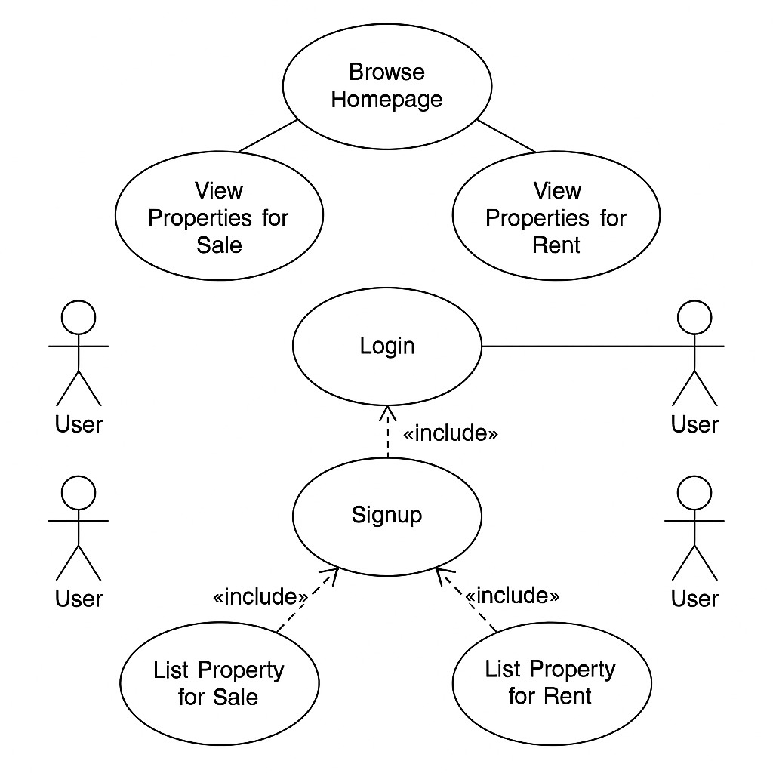

**CODE EXPLANATIION**

**HTML Structure**

The HTML file lays out the structure of the LANDLEAP website. It includes a header section with navigation links , a home section , a property section , about section. It also features a review section for customer feedback and footer section. External stylesheets and Boxicons are linked for layout and icon support.

**Header and Navigation**

The <head> tag includes the logo and navigation menu with links to different sections of the page (Home, Property, About us, Reviews, Contact us ). It also includes sign-up and sign-in buttons styled through CSS.

**Hero Section**

Welcomes visitors with a tagline and a call to action to find their dream home.

**Properties Section**

Highlights three main property services: Buy, Rent, Sell, with descriptions and links to browse listings.

**About Us**

Describes the company's mission, portfolio, and commitment to transparency and innovation.

**Reviews**

Showcases testimonials from satisfied clients to build trust.

**Contact Us**

A form for users to send messages, including name, email, and message input fields.

**Footer**

Contains contact details and a copyright notice.

**CODE**

**index.html**

<!DOCTYPE html>

<html lang="en">

<head>

  <meta charset="UTF-8">

  <meta name="viewport" content="width=device-width, initial-scale=1.0">

  <title>LandLeap</title>

  <link rel="stylesheet" href="style.css">

  <link href='https://unpkg.com/boxicons@2.1.4/css/boxicons.min.css' rel='stylesheet'>

</head>

<body>

 <header>

        <a href="index.html" class="logo">

            <img src="images/Logo.jpg" alt="Logo">

            <span class="site-name">LandLeap</span>

        </a>

        <ul class="navbar">

            <li><a href="#Home">Home</a></li>

            <li><a href="#properties">Properties</a></li>

            <li><a href="#about">About Us</a></li>

            <li><a href="#reviews">Reviews</a></li>

            <li><a href="#contact">Contact Us</a></li>

        </ul>

        <div class="header-btn">

            <a href="login.html" class="login-btn">Login</a>

            <a href="signup.html" class="sign-up">Sign Up</a>

        </div>

    </header>

    <section class="Home" id="Home">

      <div class="slideshow-container">

    <img src="images/slider1.jpg" class="bg-slide active" alt="Slide 1">

    <img src="images/slider2.jpg" class="bg-slide" alt="Slide 2">

    <img src="images/slider3.jpg" class="bg-slide" alt="Slide 3">

    <img src="images/slider4.jpg" class="bg-slide" alt="Slide 3">

    <img src="images/slider5.jpg" class="bg-slide" alt="Slide 3">

  </div>

        <div class="text">

          <h1 class="welcome-msg">Welcome to <span>LandLeap!</span></h1>

            <h1>Find Your <br>

                <span>Dream Home </span>today!

            </h1>

            <p>

                Buy, Rent or Sell properties with ease and confidence

            </p>

        </div>

    </section>

<section class="properties" id="properties">

  <h1 class="heading">PROPERTIES</h1>

  <div class="container">

    <!-- Buy Card -->

    <div class="card buy">

      <img src="images/buy.png" alt="Buy">

      <div class="card-content">

        <h3 class="card-title">Buy</h3>

        <p class="card-desc">

          Find your place with an immersive photo experience and the most listings, including things you won’t find anywhere else.

        </p>

        <a href="buy.html">

          <button>Browse Properties</button>

        </a>

      </div>

    </div>

    <!-- Rent Card -->

    <div class="card rent">

      <img src="images/rent.png" alt="Rent">

      <div class="card-content">

        <h3 class="card-title">Rent</h3>

        <p class="card-desc">

          We’re creating a seamless online experience – from shopping on the largest rental network, to applying, to paying rent.

        </p>

        <a href="rent.html">

          <button>Find Rentals</button>

        </a>

      </div>

    </div>

    <!-- Sell Card -->

    <div class="card sell">

      <img src="images/sell.png" alt="Sell">

      <div class="card-content">

        <h3 class="card-title">Sell</h3>

        <p class="card-desc">

          No matter what path you take to sell your property, we can help you navigate a successful sale.

        </p>

        <a href="sell.html">

          <button>See Your Options</button>

        </a>

      </div>

    </div>

  </div>

</section>

<section class="about-us-section" id="about">

    <h1>ABOUT US</h1>

    <div class="about-wrapper">

      <div class="about-img">

        <img src="images/Person.jpg" alt="Land Leap Founder" />

      </div>

      <div class="about-text">

        <h3>Land Leap</h3>

        <p>

          Land Leap is a dynamic real estate venture driven by innovation and trust. We help you discover the perfect land, home, or investment with clarity, professionalism, and deep market knowledge.

        </p>

        <p>

          Our portfolio includes residential plots, commercial properties, and future-ready developments. With transparency and speed at our core, Land Leap is your gateway to smart property decisions.

        </p>

        <p>

          We're dedicated to reshaping the way people interact with land — making ownership smarter, faster, and more accessible.

        </p>

        <a href="https://wa.me/7816041920" target="_blank" class="whatsapp-btn">Whatsapp at 7816041920</a>

      </div>

    </div>

</section>

<section class="stats-section">

  <h2>Our Achievements</h2>

  <div class="stats-wrapper">

    <div class="stat-box">

      <span class="counter" data-target="850">40+</span>

      <p>Properties Sold</p>

    </div>

    <div class="stat-box">

      <span class="counter" data-target="470">20+</span>

      <p>Happy Clients</p>

    </div>

    <div class="stat-box">

      <span class="counter" data-target="120">25+</span>

      <p>Agents & Partners</p>

    </div>

  </div>

</section>

 <!--Reviews-->

    <section class="reviews" id="reviews">

        <div class="rev-heading">

            <span>R E V I E W S</span>

            <h1 >Echoes of Satisfaction</h1>

        </div>

        <div class="reviews-container">

            <div class="box">

                <div class="rev-img">

                    <img src="images/revImg1.jpg" alt="Customer 1">

                </div>

                <h2>Murph Cooper</h2>

                <div class="stars">

                    <i class="bx bxs-star"></i>

                    <i class="bx bxs-star"></i>

                    <i class="bx bxs-star"></i>

                    <i class="bx bxs-star-half"></i>

                </div>

                <p>"LandLeap didn’t just help me find land — it helped me build a legacy. The process was seamless, the listings transparent, and I finally found a plot that feels like home... even across timezones. Gravity may be relative, but LandLeap's service is absolutely grounded."</p>

            </div>

            <div class="box">

                <div class="rev-img">

                    <img src="images/revImg2.jpg" alt="Customer 2">

                </div>

                <h2>Neil Donovan</h2>

                <div class="stars">

                    <i class="bx bxs-star"></i>

                    <i class="bx bxs-star"></i>

                    <i class="bx bxs-star"></i>

                    <i class="bx bxs-star"></i>

                    <i class="bx bxs-star"></i>

                </div>

                <p>"I’ve moved between countries, timelines, and investments. LandLeap was the only constant that made sense. Clean interface, high-yield listings, and no temporal paradoxes. I closed two deals in real time — and reverse. Highly recommend."</p>

            </div>

            <div class="box"><div class="rev-img">

                    <img src="images/revImg3.jpg" alt="Customer 3">

                </div>

                <h2>Lois Cooper</h2>

                <div class="stars">

                    <i class="bx bxs-star"></i>

                    <i class="bx bxs-star"></i>

                    <i class="bx bxs-star"></i>

                    <i class="bx bxs-star"></i>

                    <i class="bx bxs-star-half"></i>

                </div>

                <p>"At my age, clarity and trust mean everything. LandLeap gave me both. I was guided with patience, the documentation was spotless, and today I’m sipping chai on the porch of a house I thought I’d never own. It's never too late to make the right move."</p>

            </div>

        </div>

    </section>

    <section class="rating-section">

    <h2>How would you rate us?</h2>

    <div class="star-rating">

        <input type="radio" name="rate" id="rate-5">

        <label for="rate-5" class="bx bxs-star"></label>

        <input type="radio" name="rate" id="rate-4">

        <label for="rate-4" class="bx bxs-star"></label>

        <input type="radio" name="rate" id="rate-3">

        <label for="rate-3" class="bx bxs-star"></label>

        <input type="radio" name="rate" id="rate-2">

        <label for="rate-2" class="bx bxs-star"></label>

        <input type="radio" name="rate" id="rate-1">

        <label for="rate-1" class="bx bxs-star"></label>

    </div>

</section>

<!--Contact Us -->

<section class="contact" id="contact">

    <div class="heading">

      <h1>Contact Us</h1>

    </div>

    <div class="contact-wrapper">     <!--A flex container that wraps the form and the contact info side by side-->

      <!-- Message Form -->

      <div class="form-container">   <!--box holding the contact form-->

        <h2>Send us message</h2>

<form action="https://docs.google.com/forms/d/e/1FAIpQLSc1iHhssDI2yKHUalB2HfQSOhDmX9Ro9-rKnlHl6cfsyc8PJg/formResponse"

      method="POST"

      target="hidden_iframe"

      onsubmit="document.getElementById('thankYouMessage').style.display = 'flex'; this.style.display = 'none';">

  <input type="text" name="entry.781242607" placeholder="Full Name" required />

  <input type="email" name="entry.887857042" placeholder="Your Email" required />

  <input type="text" name="entry.1443511878" placeholder="Your Contact No" required />

  <textarea name="entry.660114977" placeholder="Your Message" rows="4" required></textarea>

  <button type="submit">Submit</button>

</form>

<iframe name="hidden_iframe" style="display:none;"></iframe>

        <div class="thank-you-msg" id="thankYouMessage">

          <div class="tick-circle">

            <i class='bx bx-check'></i>

          </div>

          <p>Thank you! Your message has been sent.</p>

        </div>

      </div>

      <!-- Owner Info & Social Links -->

      <div class="master-card">

      <div class="form-container owner-card">

        <h2>Reach Us Out At</h2>

        <h3>Uppalapati Prabhas</h3>

        <p><i class="bx bx-phone"></i>: 2898100028</p>

        <p><i class="bx bx-envelope"></i>: karna@mahabarat.com</p>

        <div class="app-stores">

          <a href="https://www.apple.com/in/app-store/" target="_blank"><img src="images/AppStore.jpg" alt="Download on App Store"></a>

          <a href="https://play.google.com/store/games?hl=en_IN" target="_blank"><img src="images/PlayStore.jpg" alt="Get it on Google Play"></a>

        </div>

        <div class="social">

          <a href="facebook.com"><i class="bx bxl-facebook"></i></a>

          <a href="x.com"><i class="bx bxl-twitter"></i></a>

          <a href="instagram.com"><i class="bx bxl-instagram"></i></a>

          <a href="whatsapp.com"><i class="bx bxl-whatsapp"></i></a>

        </div>

      </div>

      </div>

    </div>

  </section>

<footer class="footer">

    <p>&copy; 2025 LandLeap. All rights reserved.</p>

  </footer>

   <script>

  // ---------- Slideshow ----------

  let slideIndex = 0;

  const slides = document.querySelectorAll(".bg-slide");

  function cycleSlides() {

    slides.forEach(slide => slide.classList.remove("active"));

    slideIndex = (slideIndex + 1) % slides.length;

    slides[slideIndex].classList.add("active");

  }

  // Show the first slide

  slides[0].classList.add("active");

  // Start slideshow every 3 seconds

  setInterval(cycleSlides, 3000);

 </script>

<!-- ---------- Tawk.to Chat Integration ---------- -->

<script type="text/javascript">

  var Tawk_API = Tawk_API || {}, Tawk_LoadStart = new Date();

  (function () {

    var s1 = document.createElement("script"), s0 = document.getElementsByTagName("script")[0];

    s1.async = true;

    s1.src = 'https://embed.tawk.to/686771c6f389bf19111c3afd/1iva18sc2';

    s1.charset = 'UTF-8';

    s1.setAttribute('crossorigin', '*');

    s0.parentNode.insertBefore(s1, s0);

  })();

</script>

  </body>

</html>

**buy.html**

<!DOCTYPE html>

<html lang="en">

<head>

    <meta charset="UTF-8">

    <meta name="viewport" content="width=device-width, initial-scale=1.0">

    <link href='https://unpkg.com/boxicons@2.1.4/css/boxicons.min.css' rel='stylesheet'>

    <link rel="stylesheet" href="properties.css">

    <title>Buy</title>

</head>

<body>

     <nav class="navbar">

    <div class="logo">

        <img src="/images/Logo.jpg">

    </div>

    <div class="search-container">

      <select name="location" id="location">

        <option value="" disabled selected>Select Location</option>

        <option value="hyderabad">Hyderabad</option>

        <option value="bangalore">Bangalore</option>

        <option value="mumbai">Mumbai</option>

        <option value="chennai">Chennai</option>

      </select>

      <select name="category" id="category">

        <option value="" disabled selected>Select Type</option>

        <option value="apartment">Apartments</option>

        <option value="individual">Individual Houses</option>

        <option value="landscape">LandScapes</option>

      </select>

      <button type="submit">Search</button>

    </div>

  </nav>

    <div class="buy-container1"  id="hyd individual">

         <div class="image-container" data-location="hyderabad" data-category="apartment">

         <div class="card">

        <img src="/img-buy/apt-1.jpg">

        <div class="info">

        <h2>Cybercity Villa Verde</h2>

        <p>Hitech City, Hyderabad</p>

        <p>4, 5 BHK </p>

        <strong>Price on Request</strong><br>

       <a href="pd-1.html" class="button">Contact</a>

         </div>

         </div>

         </div>

        <div class="image-container" data-location="hyderabad" data-category="apartment">

         <div class="card">

        <img src="/img-buy/apt-2.jpg">

        <div class="info">

        <h2>Green Apartments</h2>

        <p>Ameerpet, Hyderabad</p>

        <p>1, 2 BHK </p>

        <strong>Price on Request</strong><br>

        <a href="pd-2.html" class="button">Contact</a>

         </div>

         </div>

         </div>

        <div class="image-container" data-location="hyderabad" data-category="apartment">

         <div class="card">

        <img src="/img-buy/apt-3.jpg">

        <div class="info">

        <h2>City Apartments</h2>

        <p>kukatpally, Hyderabad</p>

        <p>1 BHK </p>

        <strong>Price on Request</strong><br>

       <a href="pd-3.html" class="button">Contact</a>

         </div>

         </div>

         </div>

    </div>

    <div class="buy-container1" id="hyd individual">

         <div class="image-container" data-location="hyderabad" data-category="individual">

         <div class="card">

        <img src="/img-buy/idh-1.jpg">

        <div class="info">

        <h2>mukundha nilayam</h2>

        <p>Road no-2 , madhapur,Hyderabad</p>

        <strong>Price on Request</strong><br>

        <a href="pd-4.html" class="button">Contact</a>

         </div>

         </div>

         </div>

        <div class="image-container" data-location="hyderabad" data-category="individual">

         <div class="card">

        <img src="/img-buy/idh-2.jpg">

        <div class="info">

        <h2>krishna nilayam</h2>

        <p>opp grand hotel,Hyderabad</p>

        <strong>Price on Request</strong><br>

        <a href="pd-5.html" class="button">Contact</a>

         </div>

         </div>

         </div>

        <div class="image-container" data-location="hyderabad" data-category="individual">

         <div class="card">

        <img src="/img-buy/idh-3.jpg">

        <div class="info">

        <h2>radha nilayam</h2>

        <p>House 78-34-21, Sree Ram Colony,Hyderabad</p>

        <strong>Price on Request</strong><br>

        <a href="pd-6.html" class="button">Contact</a>

         </div>

         </div>

         </div>

    </div>

    <div class="buy-container1" id="Bengulur lands">

         <div class="image-container" data-location="bangalore" data-category="landscape">

         <div class="card">

        <img src="img-buy/land 1.jpeg">

        <div class="info">

        <p>Plot No. 23, Poonam Street,Bengulur</p>

        <strong>Price on Request</strong><br>

        <a href="https://wa.me/7816041920" target="_blank" class="button">Contact</a>

         </div>

         </div>

         </div>

        <div class="image-container" data-location="bangalore" data-category="landscape">

         <div class="card">

        <img src="/img-buy/land 2.jpg">

        <div class="info">

        <p>Plot No. 34, Green Fields Colony,Benglur</p>

        <strong>Price on Request</strong><br>

        <a href="https://wa.me/7816041920" target="_blank" class="button">Contact</a>

         </div>

         </div>

         </div>

        <div class="image-container" data-location="bangalore" data-category="landscape">

         <div class="card">

        <img src="/img-buy/land 3.jpeg">

        <div class="info">

        <p>No. 56-78-90, Mountain Breeze Villas,Benglur</p>

        <strong>Price on Request</strong><br>

        <a href="https://wa.me/7816041920" target="_blank" class="button">Contact</a>

         </div>

         </div>

         </div>

    </div>

    <!---->

    <div class="buy-container1" id="Mum Apartments">

         <div class="image-container" data-location="mumbai" data-category="apartment">

         <div class="card">

        <img src="/img-buy/apt-4.jpg">

        <div class="info">

        <h2>Sanjana Apartments</h2>

        <p>Mumbai</p>

        <p>4, 5 BHK </p>

        <strong>Price on Request</strong><br>

        <a href="https://wa.me/7816041920" target="_blank" class="button">Contact</a>

         </div>

         </div>

         </div>

        <div class="image-container" data-location="mumbai" data-category="apartment">

         <div class="card">

        <img src="/img-buy/apt-5.jpg">

        <div class="info">

        <h2>Green Apartments</h2>

        <p>Mumbai</p>

        <p>1, 2 BHK </p>

        <strong>Price on Request</strong><br>

        <a href="https://wa.me/7816041920" target="_blank" class="button">Contact</a>

         </div>

         </div>

         </div>

        <div class="image-container" data-location="mumbai" data-category="apartment">

         <div class="card">

        <img src="/img-buy/apt-6.jpg">

        <div class="info">

        <h2>City Apartments</h2>

        <p>Mumbai</p>

        <p>1 BHK </p>

        <strong>Price on Request</strong><br>

        <a href="https://wa.me/7816041920" target="_blank" class="button">Contact</a>

         </div>

         </div>

         </div>

    </div>

    <div class="buy-container1" id="chennai individual">

         <div class="image-container" data-location="chennai" data-category="individual">

         <div class="card">

        <img src="/img-buy/idh-4.jpg">

        <div class="info">

        <h2>SreeSai nilayam</h2>

        <p>Road no-5 ,Chennai</p>

        <strong>Price on Request</strong><br>

        <a href="https://wa.me/7816041920" target="_blank" class="button">Contact</a>

         </div>

         </div>

         </div>

        <div class="image-container" data-location="chennai" data-category="individual">

         <div class="card">

        <img src="/img-buy/idh-5.jpg">

        <div class="info">

        <h2>Venkatapathi House</h2>

        <p>opp grand hotel,Chennai</p>

        <strong>Price on Request</strong><br>

        <a href="https://wa.me/7816041920" target="_blank" class="button">Contact</a>

         </div>

         </div>

         </div>

        <div class="image-container" data-location="chennai" data-category="individual">

         <div class="card">

        <img src="/img-buy/idh-6.jpg">

        <div class="info">

        <h2>RaghuNandan house</h2>

        <p>House no.8,Chennai</p>

        <strong>Price on Request</strong><br>

        <a href="https://wa.me/7816041920" target="_blank" class="button">Contact</a>

         </div>

         </div>

         </div>

    </div>

    <div class="buy-container1" id="chennai lands">

         <div class="image-container" data-location="chennai" data-category="landscape">

         <div class="card">

        <img src="/img-buy/land 4.jpg">

        <div class="info">

        <p>Plot No. 85, Anjana Street,Chennai</p>

        <strong>Price on Request</strong><br>

        <a href="https://wa.me/7816041920" target="_blank" class="button">Contact</a>

         </div>

         </div>

         </div>

        <div class="image-container" data-location="chennai" data-category="landscape">

         <div class="card">

        <img src="/img-buy/land 5.jpg">

        <div class="info">

        <p>Plot No. 64, Evergreen Colony,Chennai</p>

        <strong>Price on Request</strong><br>

        <a href="https://wa.me/7816041920" target="_blank" class="button">Contact</a>

         </div>

         </div>

         </div>

        <div class="image-container" data-location="chennai" data-category="landscape">

         <div class="card">

        <img src="/img-buy/land 6.jpg">

        <div class="info">

        <p>Plot No. 56-12, Chennai</p>

        <strong>Price on Request</strong><br>

        <a href="https://wa.me/7816041920" target="_blank" class="button">Contact</a>

         </div>

         </div>

         </div>

    </div>

    <div class="buy-container1" id="Bengulur Apartments ">

         <div class="image-container" data-location="bangalore" data-category="apartment">

         <div class="card">

        <img src="/img-buy/apt-7.jpg">

        <div class="info">

        <h2>Waterford Apartments</h2>

        <p>Bengulur</p>

        <p>4, 5 BHK </p>

        <strong>Price on Request</strong><br>

        <a href="https://wa.me/7816041920" target="_blank" class="button">Contact</a>

         </div>

         </div>

         </div>

        <div class="image-container" data-location="bangalore" data-category="apartment">

         <div class="card">

        <img src="/img-buy/apt-8.jpg">

        <div class="info">

        <h2>Raintree Apartments</h2>

        <p>Benguluru</p>

        <p>1, 2 BHK </p>

        <strong>Price on Request</strong><br>

        <a href="https://wa.me/7816041920" target="_blank" class="button">Contact</a>

         </div>

         </div>

         </div>

        <div class="image-container" data-location="bangalore" data-category="apartment">

         <div class="card">

        <img src="/img-buy/apt-9.jpg">

        <div class="info">

        <h2> Green Gables Apartments</h2>

        <p>Bengulur</p>

        <strong>Price on Request</strong><br>

        <a href="https://wa.me/7816041920" target="_blank" class="button">Contact</a>

         </div>

         </div>

         </div>

    </div>

    <div class="buy-container1" id="chennai Apartments">

         <div class="image-container" data-location="chennai" data-category="apartment">

         <div class="card">

        <img src="/img-buy/apt-10.jpg">

        <div class="info">

        <h2>Oak Street Apartments</h2>

        <p>Chennai</p>

        <p>4, 5 BHK </p>

        <strong>Price on Request</strong><br>

        <a href="https://wa.me/7816041920" target="_blank" class="button">Contact</a>

         </div>

         </div>

         </div>

        <div class="image-container" data-location="chennai" data-category="apartment">

         <div class="card">

        <img src="/img-buy/apt-11.jpg">

        <div class="info">

        <h2>The Residency Apartments</h2>

        <p>Chennai</p>

        <p>1, 2 BHK </p>

        <strong>Price on Request</strong><br>

        <a href="https://wa.me/7816041920" target="_blank" class="button">Contact</a>

         </div>

         </div>

         </div>

        <div class="image-container" data-location="chennai" data-category="apartment">

         <div class="card">

        <img src="/img-buy/apt-12.jpg">

        <div class="info">

        <h2>Sahana Apartments</h2>

        <p>Chennai</p>

        <p>2 BHK </p>

        <strong>Price on Request</strong><br>

        <a href="https://wa.me/7816041920" target="_blank" class="button">Contact</a>

         </div>

         </div>

         </div>

    </div>

    <a href="index.html"><button class="bt1" style="width:200px;border-radius:10px;margin-left:10px;">Back</button></a>

<script>

  document.querySelector('.search-container button').addEventListener('click', function () {

    const selectedLocation = document.getElementById('location').value.toLowerCase();

    const selectedCategory = document.getElementById('category').value.toLowerCase();

    const cards = document.querySelectorAll('.image-container');

    let anyVisible = false;

    cards.forEach(card => {

      const location = card.getAttribute('data-location').toLowerCase();

      const category = card.getAttribute('data-category').toLowerCase();

      const locationMatch = !selectedLocation || location === selectedLocation;

      const categoryMatch = !selectedCategory || category === selectedCategory;

      if (locationMatch && categoryMatch) {

        card.style.display = 'block';

        anyVisible = true;

      } else {

        card.style.display = 'none';

      }

    });

    if (!anyVisible) {

      // Show alert, then refresh the page

      alert("No availability found for the selected options.");

      window.location.reload(); // Refreshes the page

    }

  });

</script>

<script>

  // ---------- Slideshow ----------

  let slideIndex = 0;

  const slides = document.querySelectorAll(".bg-slide");

  function cycleSlides() {

    slides.forEach(slide => slide.classList.remove("active"));

    slideIndex = (slideIndex + 1) % slides.length;

    slides[slideIndex].classList.add("active");

  }

  // Show the first slide

  slides[0].classList.add("active");

  // Start slideshow every 3 seconds

  setInterval(cycleSlides, 3000);

 </script>

<!-- ---------- Tawk.to Chat Integration ---------- -->

<script type="text/javascript">

  var Tawk_API = Tawk_API || {}, Tawk_LoadStart = new Date();

  (function () {

    var s1 = document.createElement("script"), s0 = document.getElementsByTagName("script")[0];

    s1.async = true;

    s1.src = 'https://embed.tawk.to/686771c6f389bf19111c3afd/1iva18sc2';

    s1.charset = 'UTF-8';

    s1.setAttribute('crossorigin', '*');

    s0.parentNode.insertBefore(s1, s0);

  })();

</script>

</body>

</html>

**rent.html**

<!DOCTYPE html>

<html lang="en">

<head>

    <meta charset="UTF-8">

    <meta name="viewport" content="width=device-width, initial-scale=1.0">

    <link href='https://unpkg.com/boxicons@2.1.4/css/boxicons.min.css' rel='stylesheet'>

    <link rel="stylesheet" href="properties.css">

    <title>Buy</title>

</head>

<body>

     <nav class="navbar">

    <div class="logo">

        <img src="/images/Logo.jpg">

    </div>

    <div class="search-container">

      <select name="location" id="location">

        <option value="">Select Location</option>

        <option value="hyderabad">Hyderabad</option>

        <option value="bangalore">Bangalore</option>

        <option value="chennai">Chennai</option>

      </select>

      <select name="category" id="category">

        <option value="">Select Type</option>

        <option value="apartment">Apartment</option>

        <option value="independent house">Independent House</option>

      </select>

      <button type="submit">Search</button>

    </div>

  </nav>

    <div class="buy-container1">

         <div class="image-container" data-location="hyderabad" data-category="apartment">

         <div class="card">

        <img src="/img-rent/apt1.jpeg">

        <div class="info">

        <h2>Sunset Gardens, Road No. 8, Madhapur</h2>

        <p>hyderabad</p>

        <p>4, 5 BHK </p>

        <strong>Price on Request</strong><br>

        <a href="https://wa.me/7816041920" target="_blank" class="button">Contact</a>

         </div>

         </div>

         </div>

         <div class="image-container" data-location="hyderabad" data-category="apartment">

         <div class="card">

        <img src="img-rent/apt-5.jpg">

        <div class="info">

        <h2>102, Lakeside Land, ECR Road, Neelangarai</h2>

        <p>Hyderabad</p>

        <strong>Price on Request</strong><br>

        <a href="https://wa.me/7816041920" target="_blank" class="button">Contact</a>

         </div>

         </div>

</div>

         <div class="image-container" data-location="hyderabad" data-category="apartment">

         <div class="card">

        <img src="img-rent/apt-4.jpg">

        <div class="info">

        <h2>Silver Oak Complex, Street 5, Kondapur</h2>

        <p>Hyderabad</p>

        <strong>Price on Request</strong><br>

        <a href="https://wa.me/7816041920" target="_blank" class="button">Contact</a>

         </div>

         </div>

         </div>

    </div>

    <div class="buy-container1">

         <div class="image-container" data-location="bangalore" data-category="independent house">

         <div class="card">

        <img src="img-rent/idh-2.jpg">

        <div class="info">

        <h2>8, Greenfield Residency, Koramangala</h2>

        <p> Bangalore</p>

        <strong>Price on Request</strong><br>

        <a href="https://wa.me/7816041920" target="_blank" class="button">Contact</a>

         </div>

         </div>

         </div>

         <div class="image-container" data-location="bangalore" data-category="independent house">

         <div class="card">

        <img src="img-rent/idh-3.jpg">

        <div class="info">

        <h2>27, Riverside Heights, Whitefield</h2>

        <p> Bangalore</p>

        <strong>Price on Request</strong><br>

        <a href="https://wa.me/7816041920" target="_blank" class="button">Contact</a>

         </div>

         </div>

         </div>

          <div class="image-container" data-location="bangalore" data-category="independent house">

         <div class="card">

        <img src="img-rent/idh-6.jpg">

        <div class="info">

        <h2>8, Greenfield Residency, Koramangala</h2>

        <p> Bangalore</p>

        <strong>Price on Request</strong><br>

        <a href="https://wa.me/7816041920" target="_blank" class="button">Contact</a>

         </div>

         </div>

         </div>

    </div>

    <div class="buy-container1">

        <div class="image-container" data-location="chennai" data-category="independent house">

         <div class="card">

        <img src="img-rent/idh-4.jpg">

        <div class="info">

        <h2>89, Lakeview Road, Ashok Nagar</h2>

        <p> Chennai</p>

        <strong>Price on Request</strong><br>

        <a href="https://wa.me/7816041920" target="_blank" class="button">Contact</a>

         </div>

         </div>

         </div>

        <div class="image-container" data-location="chennai" data-category="independent house">

         <div class="card">

        <img src="img-rent/idh-5.jpg">

        <div class="info">

        <h2>56, Greenfield Villas, Chromepet</h2>

        <p> Chennai</p>

        <strong>Price on Request</strong><br>

        <a href="https://wa.me/7816041920" target="_blank" class="button">Contact</a>

         </div>

         </div>

         </div>

         <div class="image-container" data-location="chennai" data-category="independent house">

         <div class="card">

        <img src="img-rent/idh-1.jpg">

        <div class="info">

        <h2>102, Blossom Street, Adyar</h2>

        <p> Chennai</p>

        <strong>Price on Request</strong><br>

        <a href="https://wa.me/7816041920" target="_blank" class="button">Contact</a>

         </div>

         </div>

         </div>

    </div>

    <div class="buy-container1">

        <div class="image-container" data-location="bangalore" data-category="apartment">

         <div class="card">

        <img src="img-rent/apt-6.jpg">

        <div class="info">

        <h2>58, Hillview Land, Nandi Hills</h2>

        <p> Bangalore</p>

        <strong>Price on Request</strong><br>

        <a href="https://wa.me/7816041920" target="_blank" class="button">Contact</a>

         </div>

         </div>

         </div>

         <div class="image-container" data-location="bangalore" data-category="apartment">

         <div class="card">

        <img src="img-rent/apt-3.jpeg">

        <div class="info">

        <h2>Sunrise Residency, 90, BTM Layout</h2>

        <p>Bangalore</p>

        <p>1, 2 BHK </p>

        <strong>Price on Request</strong><br>

        <a href="https://wa.me/7816041920" target="_blank" class="button">Contact</a>

         </div>

         </div>

         </div>

         <div class="image-container" data-location="bangalore" data-category="apartment">

         <div class="card">

        <img src="img-rent/apt-2.jpg">

        <div class="info">

        <h2>Skyline Apartments, 102, HSR Layout Bangalore</h2>

        <p>Bangalore</p>

        <p>1, 2 BHK </p>

        <strong>Price on Request</strong><br>

        <a href="https://wa.me/7816041920" target="_blank" class="button">Contact</a>

         </div>

         </div>

         </div>

    </div>

<script>

  document.querySelector('.search-container button').addEventListener('click', function () {

    const selectedLocation = document.getElementById('location').value.toLowerCase();

    const selectedCategory = document.getElementById('category').value.toLowerCase();

    const cards = document.querySelectorAll('.image-container');

    let anyVisible = false;

    cards.forEach(card => {

      const location = card.getAttribute('data-location').toLowerCase();

      const category = card.getAttribute('data-category').toLowerCase();

      const locationMatch = !selectedLocation || location === selectedLocation;

      const categoryMatch = !selectedCategory || category === selectedCategory;

      if (locationMatch && categoryMatch) {

        card.style.display = 'block';

        anyVisible = true;

      } else {

        card.style.display = 'none';

      }

    });

    if (!anyVisible) {

      // Show alert, then refresh the page

      alert("No availability found for the selected options.");

      window.location.reload(); // Refreshes the page

    }

  });

</script>

<script>

  // ---------- Slideshow ----------

  let slideIndex = 0;

  const slides = document.querySelectorAll(".bg-slide");

  function cycleSlides() {

    slides.forEach(slide => slide.classList.remove("active"));

    slideIndex = (slideIndex + 1) % slides.length;

    slides[slideIndex].classList.add("active");

  }

  // Show the first slide

  slides[0].classList.add("active");

  // Start slideshow every 3 seconds

  setInterval(cycleSlides, 3000);

 </script>

<!-- ---------- Tawk.to Chat Integration ---------- -->

<script type="text/javascript">

  var Tawk_API = Tawk_API || {}, Tawk_LoadStart = new Date();

  (function () {

    var s1 = document.createElement("script"), s0 = document.getElementsByTagName("script")[0];

    s1.async = true;

    s1.src = 'https://embed.tawk.to/686771c6f389bf19111c3afd/1iva18sc2';

    s1.charset = 'UTF-8';

    s1.setAttribute('crossorigin', '*');

    s0.parentNode.insertBefore(s1, s0);

  })();

</script>

    <a href="index.html"><button class="bt1" style="width:200px;border-radius:10px;margin-left:10px;">Back</button></a>

</body>

</html>

**sell.html**

**<!DOCTYPE html>**

**<html lang="en">**

**<head>**

**<meta charset="UTF-8" />**

**<meta name="viewport" content="width=device-width, initial-scale=1.0"/>**

**<title>Sell Your Property</title>**

**<link rel="stylesheet" href="properties.css">**

**</head>**

**<body>**

**<div class="container">**

**<h1>Sell Your Property</h1>**

**<form>**

**<label for="owner">Owner Name</label>**

**<input type="text" id="owner" name="owner" placeholder="Your full name" required>**

**<label for="property-type">Property Type</label>**

**<select id="property-type" name="property-type" required>**

**<option value="">Select</option>**

**<option>Apartment</option>**

**<option>Plot</option>**

**<option>Independent House</option>**

**</select>**

**<label for="location">Location</label>**

**<input type="text" id="location" name="location" placeholder="City or Area" required>**

**<label for="price">Expected Price (INR)</label>**

**<input type="number" id="price" name="price" placeholder="e.g., 5000000" required>**

**<label for="details">Additional Details</label>**

**<textarea id="details" name="details" rows="3" placeholder="Mention area, number of rooms, etc."></textarea>**

**<button type="submit">Submit Property</button>**

**</form>**

**<div class="back-link">**

**<p><a href="index.html">← Back to Home</a></p>**

**</div>**

**</div>**

**<script>**

**// ---------- Slideshow ----------**

**let slideIndex = 0;**

**const slides = document.querySelectorAll(".bg-slide");**

**function cycleSlides() {**

**slides.forEach(slide => slide.classList.remove("active"));**

**slideIndex = (slideIndex + 1) % slides.length;**

**slides[slideIndex].classList.add("active");**

**}**

**// Show the first slide**

**slides[0].classList.add("active");**

**// Start slideshow every 3 seconds**

**setInterval(cycleSlides, 3000);**

**</script>**

**<!-- ---------- Tawk.to Chat Integration ---------- -->**

**<script type="text/javascript">**

**var Tawk_API = Tawk_API || {}, Tawk_LoadStart = new Date();**

**(function () {**

**var s1 = document.createElement("script"), s0 = document.getElementsByTagName("script")[0];**

**s1.async = true;**

**s1.src = 'https://embed.tawk.to/686771c6f389bf19111c3afd/1iva18sc2';**

**s1.charset = 'UTF-8';**

**s1.setAttribute('crossorigin', '*');**

**s0.parentNode.insertBefore(s1, s0);**

**})();**

**</script>**

**</body>**

**</html>**

**OUTPUTS OF THE WEBSITE**

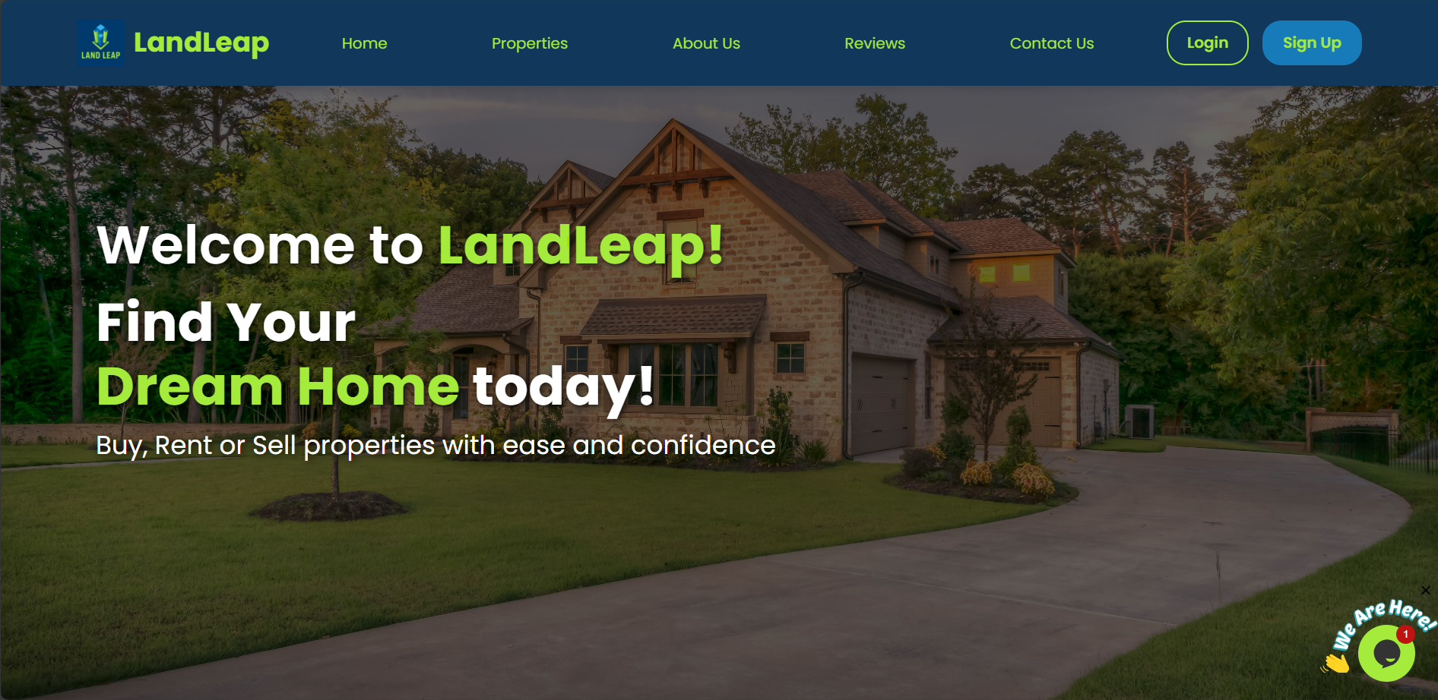

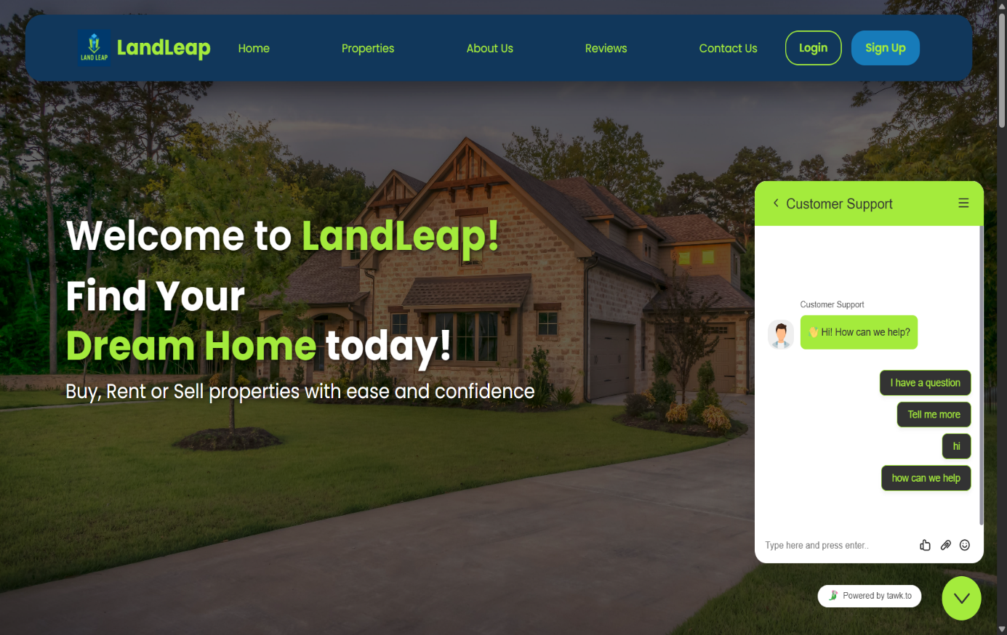

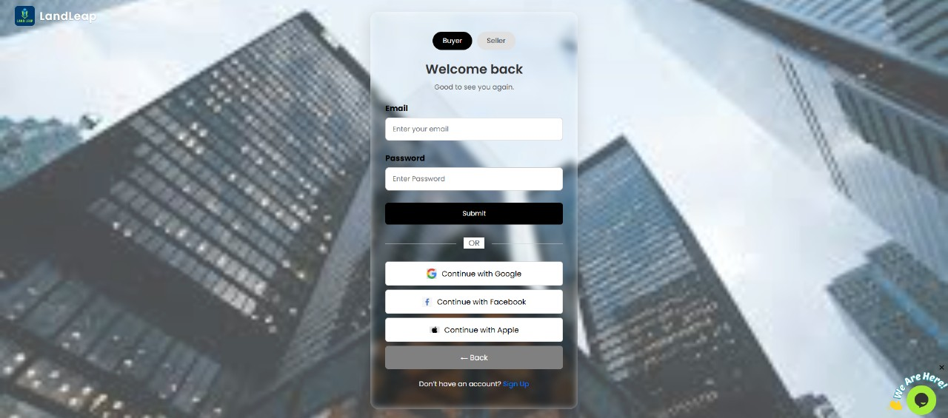

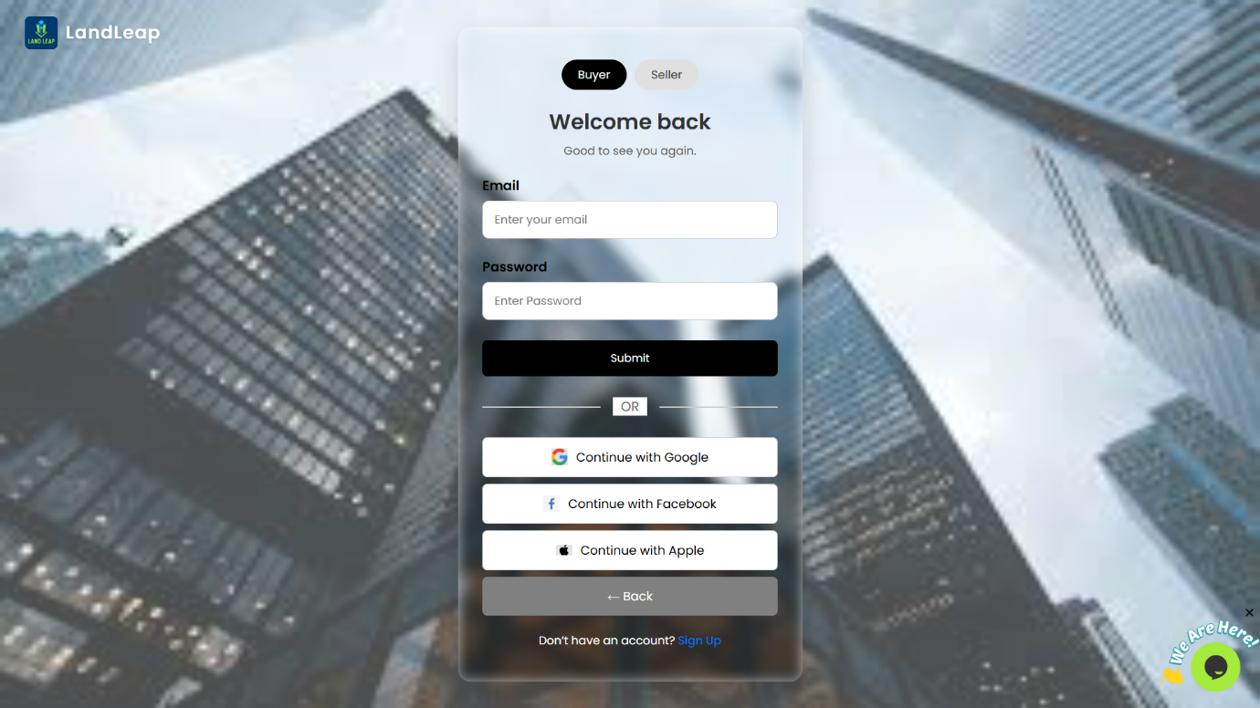

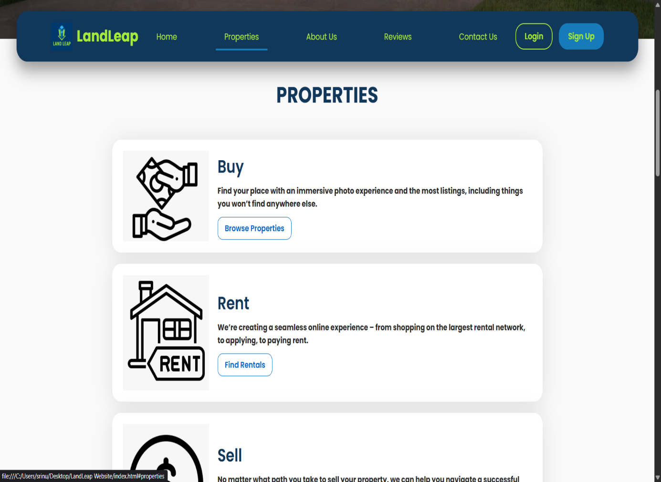

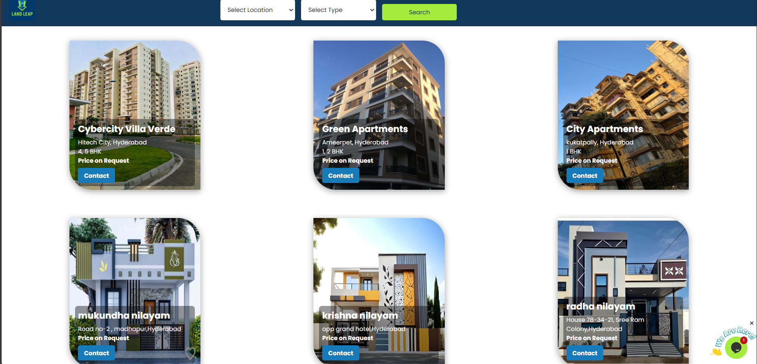

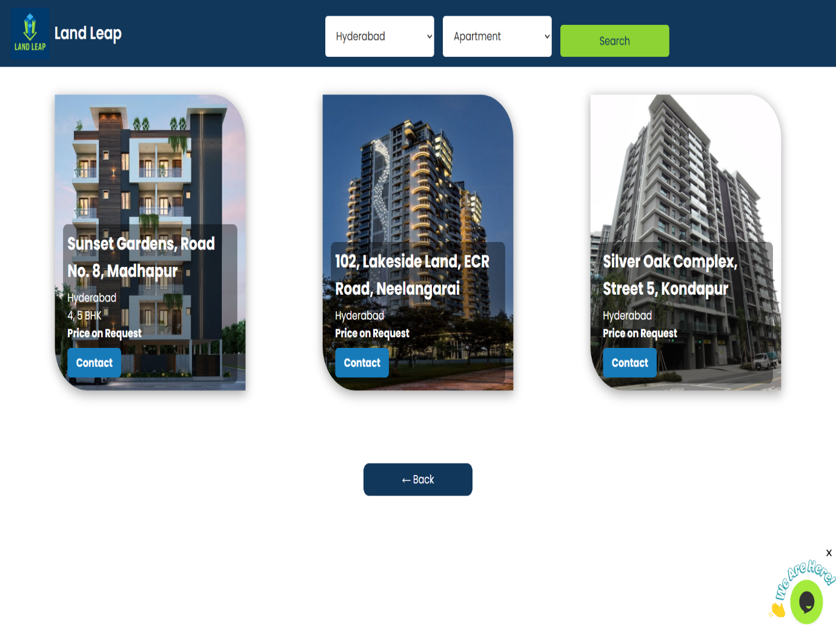

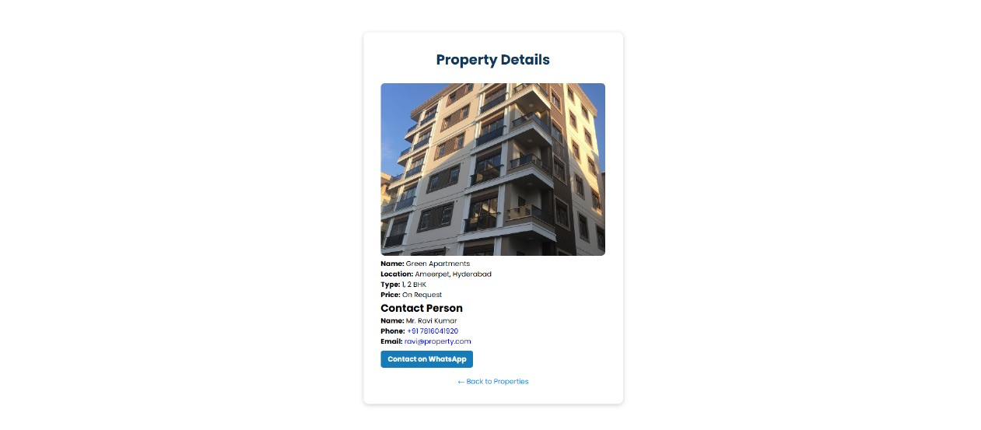

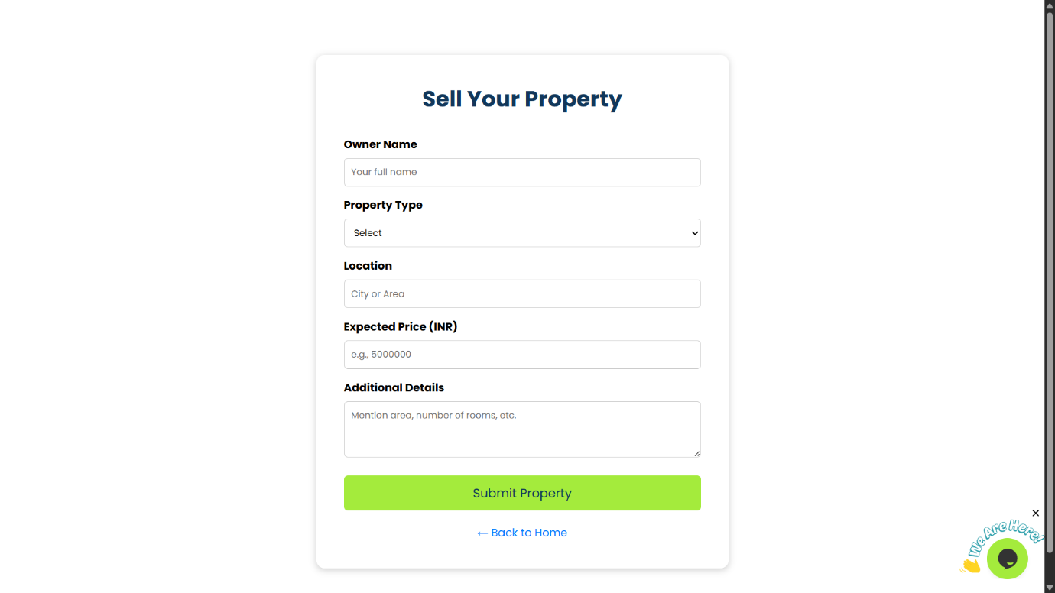

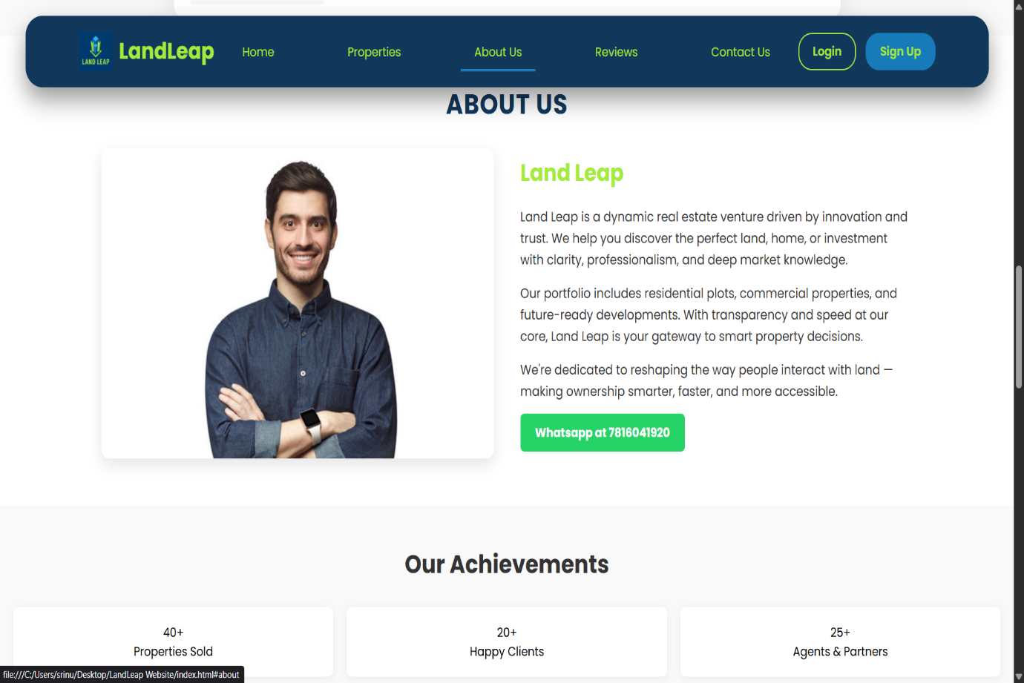

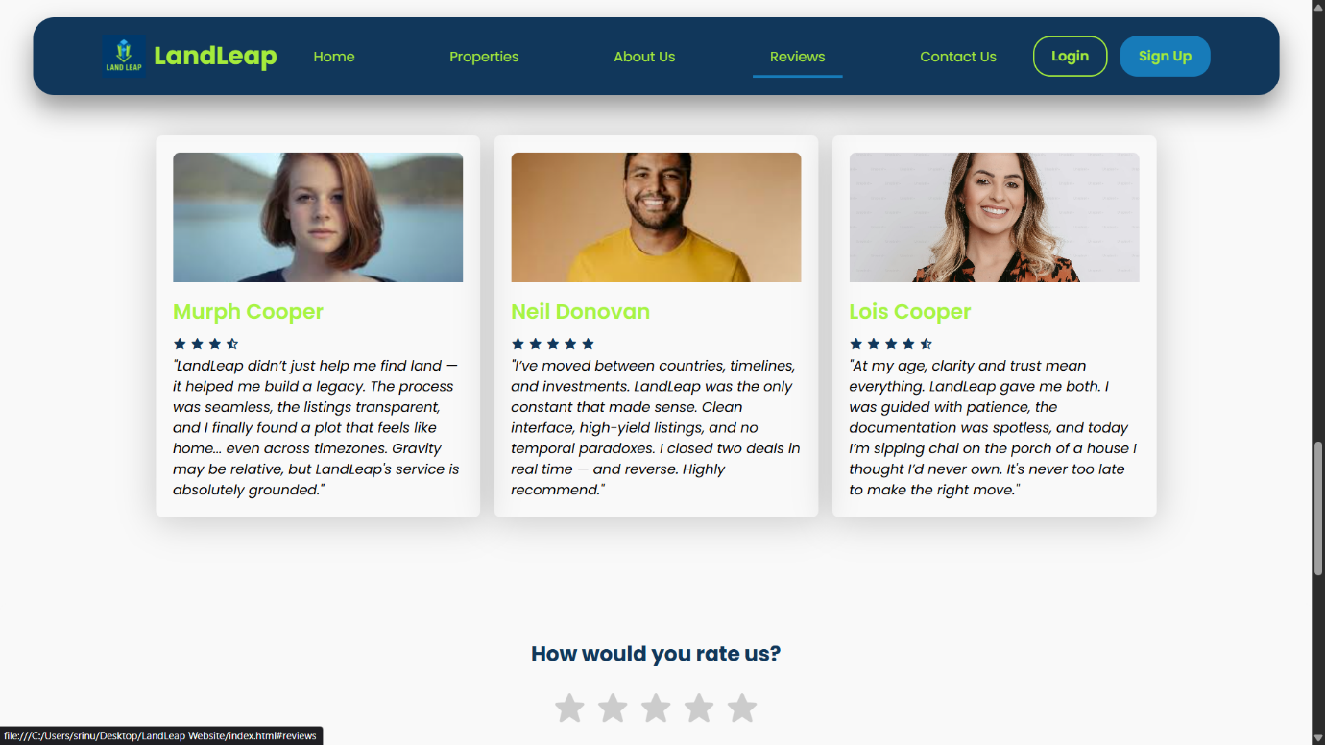

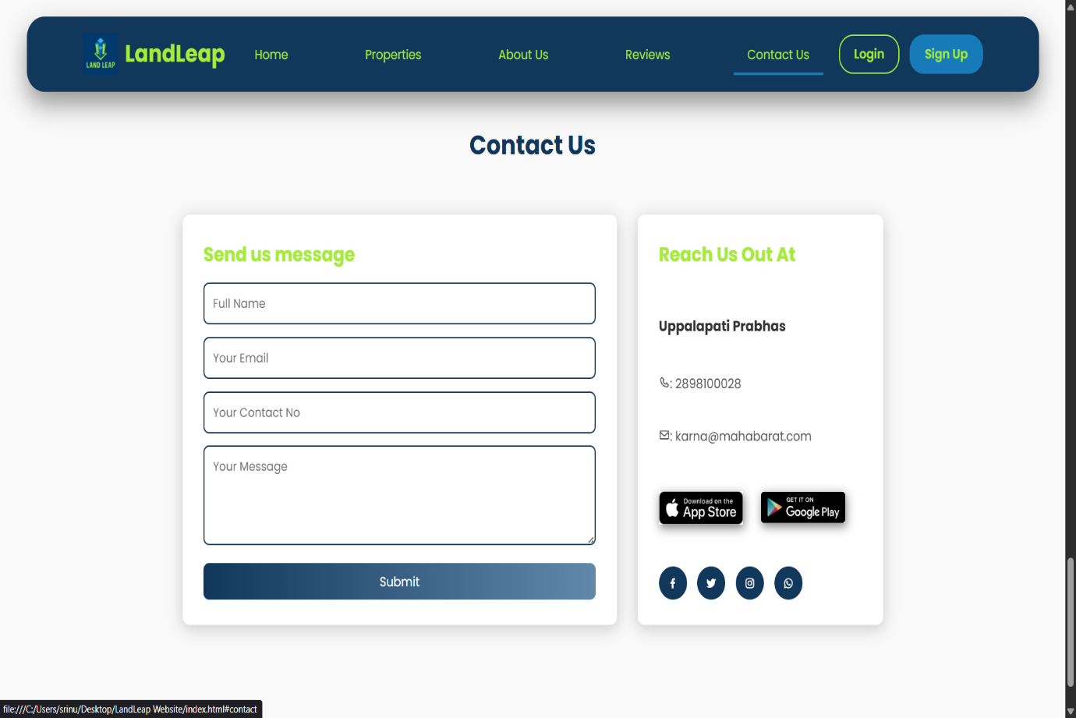

**FUTURE ENHANCEMENTS**

Integration of Advanced Technology: Incorporate GIS, remote sensing, and drone surveillance for more accurate land monitoring and management.

Community Engagement: Expand participatory planning processes to involve local communities in decision-making and land use strategies.

Policy Development: Advocate for and implement policies that promote sustainable land use, conservation, and climate resilience.

Capacity Building: Provide training and resources for local stakeholders to effectively manage land resources and adopt new technologies.

Data-driven Decision Making: Develop comprehensive data platforms to support real-time monitoring and informed decision-making.

Partnership Expansion: Collaborate with international organizations, government agencies, and private sector partners to scale project impacts.

Innovative Financing: Explore green financing mechanisms and incentives to fund sustainable land management initiatives.

**CONCLUSION**

The Land Leap Project has been a transformative initiative, demonstrating the remarkable potential of innovative land management and sustainable development practices. Through collaborative efforts and strategic planning, we have successfully enhanced land utilization, promoted environmental conservation, and supported community growth. The project has not only contributed to economic progress but also emphasized the importance of sustainable development for future generations. Moving forward, the lessons learned and the frameworks established through Land Leap will serve as a foundation for scaling similar initiatives, fostering resilient communities, and ensuring responsible stewardship of land resources worldwide. We are confident that the continued commitment and strategic implementation of this project will lead to even greater successes in the coming years.